**THE GAMING INDUSTRY VISUALIZED**

**Video Games Global Revenues $ Billion**

|  |  |
| --- | --- |
| **Year** | **Market Size** |
| 2022 | 184 |
| 2024 | 194.4 |
| 2026 | 212.1 |

**Mobile Games Take the Lead**

|  |  |
| --- | --- |
| **Market Segment** | **% Share** |
| Mobile Games | 45.5 |
| Console Games | 31.4 |
| PC Games | 20.6 |
| Other Platforms | 2.5 |
| **Total** | **100.0** |

**Offline Games Still Dominate**

|  |  |
| --- | --- |
| **Segment** | **% Share** |
| Offline | 62.4 |
| Online | 37.6 |
| Total | **100.0** |

**More Gamers More Revenues (In Billion)**

|  |  |
| --- | --- |
| **Year** | **Active Gamers (In Billion)** |
| 2020 | 2.6 |
| 2022 | 3.5 |
| 2024 | 4.1 |
| 2026 | 5.3 |

**2023 Essential Facts**

* **87%** of players agree that games provide mental stimulation
* **60%** of parents see educational games as a medium to make learning easier
* **28.3%** of generation Z identify themselves as 'gamers
* **26.3%** of global revenues comes from China
* Average spending on games rises to **$125.6** per game
* **8.27** hours per week is the time an average gamer spends playing games

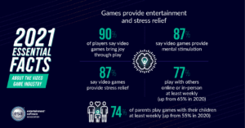

**Technologies Shaping the Future**

*\*Present the listed technologies in below design format*

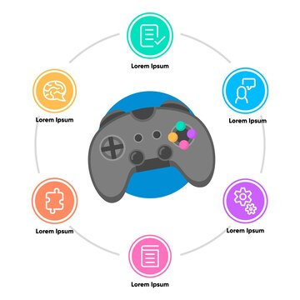

AR/VR



Cloud Gaming



Blockchain



Metaverse



Artificial Intelligence



**Trends Redefining the Coming Decade**

*(Present the listed trends in the scatter bubble chart (Sample Copied). Give icon inside each bubble along with text)*

Immersive Gaming Experiences



Social Gaming



Female Gamers



Gaming Wearables

